Snitch Fashion Sales
Project Objective:
The objective of this project is to analyze Snitch Fashion’s sales performance data to identify key revenue drivers, customer purchasing patterns, and product category trends. The project aims to uncover insights related to sales growth, profitability, discount impact, and regional performance in order to support data-driven business decisions and improve overall operational efficiency.
Dataset Description:
- Dataset has complete order information in a proper organized form with 2500 records
- Most of the product falls under 7 major categories which was ordered between 2023 to 2025 across 6 major Cities.
- Unit_price and Unit_sold cannot be negative or zero as per business logic
- Dataset has few inconsistent and missing values.
Column Description
Column Name | Description
Order_ID | Numerical value unique based on city and customer
Customer_Name | Name of the customer
Product_Category | Category of the Product
Product_Name | Name of the Product
Units_Sold | Units purchased by the customer
Unit_Price | Price of product (Unit)
Discount_% | Discount applied on the product
Sales_Amount | Total amount of the product sold
Order_Date | Date of purchase
City | City of purchase
Segment | Either B2B or B2C
Profit | Profit in currency format

Data cleaning & transformation:
Below are the columns with inconsistent and missing values, which were handle effectively using mention formulae.
Units_Sold
=IF(ISBLANK([@[Units_Sold]]),MEDIAN(E:E),IF([@[Units_Sold]]=0,MEDIAN(E:E),[@[Units_Sold]]))
Unit_Price =IF(ISBLANK([@[Unit_Price]]),AVERAGEIFS(F:F,C:C,[@[Product_Category]],K:K,[@City]),[@[Unit_Price]])
Discount_%
=IF(ISBLANK([@[Discount_%]]),0,[@[Discount_%]])
Since some values are more than 100% which is logically in valid used below to standardize
=MIN([@[Discount_%]],0.95)
Calculated a new column Revenue(Sales_Amount) with
=[@[Units_Sold]]*[@[Unit_Price]]*(1-[@[Discount_%]])
Order_Date formatted with
=DATE(RIGHT([@[Order_Date]],4),MID([@[Order_Date]],4,2),LEFT([@[Order_Date]],2))
=IF(ISBLANK([@Column1]),DATEVALUE(TEXT([@[Order_Date]],"YYYY-MM-DD")),[@Column1])
Imputed Blank Order_Date using Power query
Selected the Column Transform Tab Fill Down
City
Replace few cities to make it consistent

Visualization and Insights Arrived with screenshot of visualization
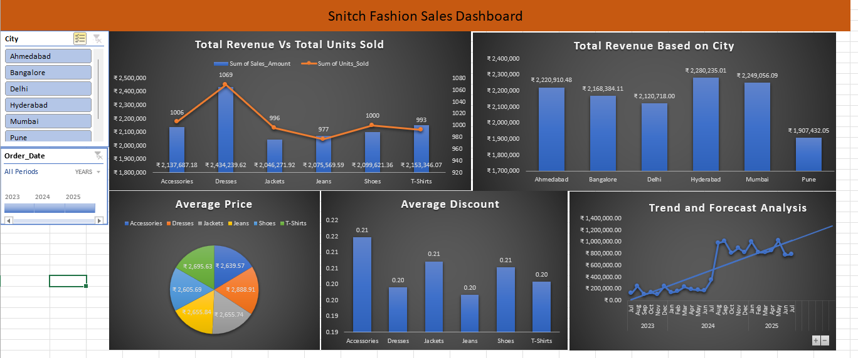
Irrespective of City, Year and Category, Dresses are the highest revenue yielding Category. Hyderabad is the top revenue generating City and Pune is the lowest revenue generating City and Dresses have the average high price.
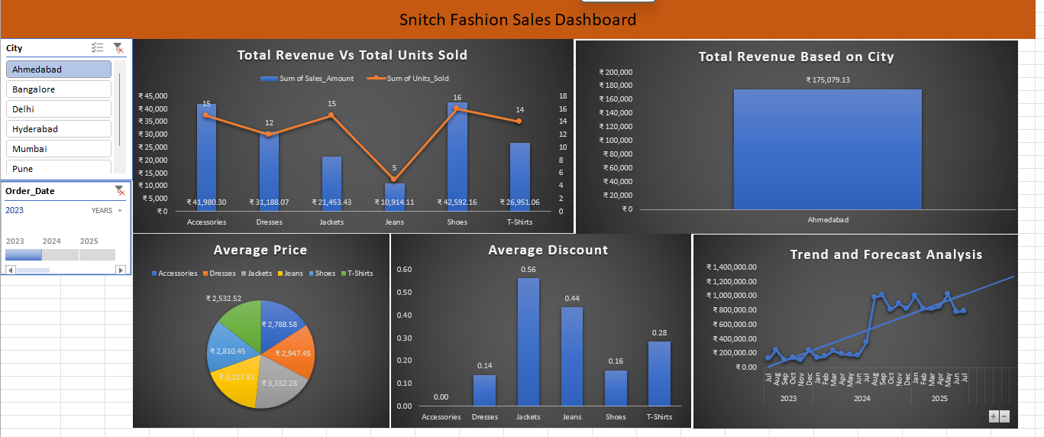
Sales happened in the year 2023 in Ahmedabad
- Shoes yield highest revenue and jeans yield the lowest revenue with low units sold
- Even though units sold in jackets is high, the revenue is comparatively low due to the discount
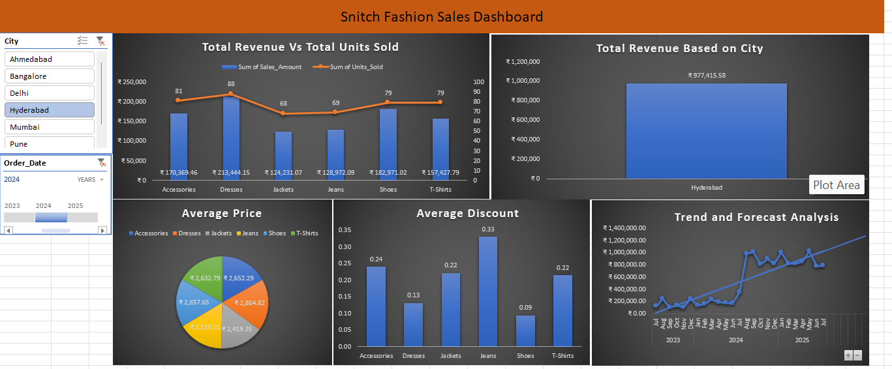
Sales happened in the year 2024 in Hyderabad
- Dresses yield the highest revenue and Jackets yield the lowest
- Considering the Units sold and average price Jackets and Jeans Should have the highest revenue but due to the average discount of those were high the revenue is affected

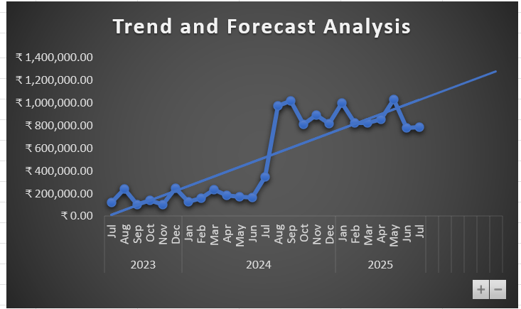

Based on the forecast Analysis the revenue yield in 2025 will be high compared to the previous years.
Discounts imposed and few categories should be standardized making sure that it wont affect the revenue generation in the upcoming months.

Conclusion:
The Fashion store should concentrate on fixing affordable price margin with standardized discounts based on the Cities will increase the units of the products sold which in-turn yields the higher revenue.

